* **Introduction:**

Email has become an essential tool for communication, both personally and professionally. However, it's also a common vector for cyber threats. In this training, we'll focus on recognizing and preventing email threats, such as phishing and malware attacks, by learning how to read email content, check sender information, verify header details, and identify risky links or attachments.

* **Section 1: Reading Email Content**
  + Check for Spelling and Grammar Errors:
    - One of the primary indicators that an email might be a phishing attempt is the presence of spelling and grammar mistakes. Cybercriminals frequently overlook these details, and their carelessness can serve as a glaring red flag. Take the time to carefully review the email content for any inaccuracies or awkward language. Legitimate organizations typically maintain a high level of professionalism in their communication, so discrepancies in spelling or grammar should raise suspicions
  + Be Wary of Urgent or Threatening Language:
    - Phishing emails often employ psychological tactics to manipulate their recipients. A common strategy is to create a false sense of urgency or use threatening language to pressure individuals into taking hasty actions. Be cautious when you encounter emails that demand immediate responses or promise dire consequences if you don't comply. Cybercriminals use fear and panic to catch victims off guard, so it's essential to approach such messages with skepticism.
  + Verify the Sender's Identity:
    - Verifying the sender's identity is a crucial step in avoiding phishing attacks. Cybercriminals are skilled at impersonating legitimate entities to gain your trust. Therefore, it's vital to cross-check the sender's email address against your expectations. Pay attention to slight variations or misspelled domain names that can be easy to overlook. If the email claims to be from a reputable source, such as a bank or a government agency, independently verify their contact information and contact them directly to confirm the legitimacy of the message. Don't rely solely on the information provided in the email; instead, take the extra step to ensure the sender is who they claim to be.
* **Section 2: Checking Sender Information**
  + 2.1 Verify the Sender's Email Address:
    - Before clicking on any links or opening attachments, hover over the sender's name or email address to reveal the full email address. Ensure that it matches the official address of the organization. If there are any discrepancies or unexpected variations, treat the email with suspicion
  + 2.2 Beware of Generic or Unusual Sender Names:
    - Be cautious if the sender's name is overly generic, such as "Administrator" or "User." Legitimate organizations typically use specific names or titles in their communications.
    - Example: Legitimate: John Doe (Administrator) - Suspicious: System Administrator
  + 2.3 Watch for Spoofed Addresses:
    - Phishers might employ slight variations of legitimate email addresses to deceive recipients. Look out for misspellings, additional characters, or changes in domain names.
    - Example:
      * Legitimate: [support@yourcompany.com](mailto:support@yourcompany.com)

Spoofed: support@yourcompnay.com

* **Section 3: Verifying Header Information**
  + 3.1 Examine Email Headers:
    - Learn to view the full email headers:
    - Gmail:
      * Open the suspicious email.
      * Click the three dots in the top-right corner.
      * Select "Show original."
    - Outlook:
      * Open the suspicious email.
      * Click on "File" and then select "Properties."
      * Look for the internet headers section.
    - Other email clients:
      * Consult your email provider's documentation to learn how to view full email headers.
    - Check for inconsistencies or anomalies:
    - Review the information in the email headers. Pay attention to the following:
      * From: Verify that the sender's information matches the visible sender details.
      * Received: Examine the sequence of servers the email passed through. Unexpected or suspicious servers may indicate phishing.
  + 3.2 Use Email Authentication Protocols:
    - Implementing email authentication protocols adds an extra layer of security to your email interactions. Ensure the organizations you engage with use the following protocols:
    - SPF (Sender Policy Framework):
      * Verifies that the sending server is authorized to send emails on behalf of a domain.
      * Check for "SPF Pass" in email headers.
    - DKIM (DomainKeys Identified Mail):
      * Ensures that the email content has not been altered in transit.
      * Look for a valid DKIM signature in the email headers.
    - DMARC (Domain-based Message Authentication, Reporting, and Conformance):
      * Provides policies for how to handle emails that fail SPF or DKIM checks.
      * Organizations should have a DMARC policy in place.
* **Section 4: Identifying Risky Links and Attachments**
  + 4.1 Hover Over Links:
    - Phishing emails often include deceptive links that can lead to malicious websites. Use these steps to protect yourself
    - Mouse over the link:
      * Hover your cursor over any included links without clicking.
      * Examine the actual URL that appears in the status bar or a tooltip.
    - Verify the URL:
      * Ensure that the displayed URL matches the expected destination.
      * Be cautious if the URL seems unrelated to the email content or if it's misspelled.
  + 4.2 Be Cautious with Attachments:
    - Attachments can be used to hide malware and other kinds of security threats. Take these precautions before opening attachments
    - Verify the sender:
      * Confirm that the sender is legitimate before opening any attachments.
      * Be wary of unexpected emails with attachments, especially if they prompt urgency.
    - Scan attachments with antivirus software:
      * Use reputable antivirus software to scan email attachments.
      * Report any suspicious attachments to your IT department.
  + 4.3 Beware of Download Requests:
    - Downloading files or running programs from unverified sources can easily lead to security breaches. Use these steps to protect yourself
    - Contact the sender:
      * Reach out to the supposed sender through a known, separate communication channel to confirm the request.
      * Avoid downloading anything until you've verified the legitimacy of the request.
    - Check the email content:
      * Be skeptical if the email conveys a sense of urgency or creates pressure to download or run something.
* **Section 5: Educate and Train:**
  + **Emphasize the Importance:**
    - Regularly communicate the significance of staying informed about evolving cybersecurity threats.
    - Highlight the dynamic nature of phishing techniques and the need for continuous education.
  + Training Content:
    - Provide sessions on recognizing phishing emails, social engineering tactics, and emerging cyber threats.
    - Include real-world examples and case studies to illustrate potential risks.
  + Interactive Learning:
    - Conduct simulated phishing exercises to allow employees to practice identifying and avoiding phishing attempts.
    - Encourage participation in workshops, webinars, or online courses to enhance cybersecurity knowledge.
  + Stay Updated:
    - Stress the importance of staying current with cybersecurity trends.
    - Provide resources and references for employees to self-educate on the latest threats.
  + Establish clear reporting procedures for suspicious emails. Employees should know how to report potential threats to IT or security teams.
  + Clear Reporting Channels:
    - Establish clear and accessible reporting channels for suspicious emails.
    - Ensure employees know how and where to report potential threats – whether through an email alias, dedicated reporting tool, or directly to the IT or security teams.
  + Encourage Timely Reporting:
    - Emphasize the importance of reporting suspicious emails promptly.
    - Make it clear that reporting contributes to the overall security of the organization.
  + Anonymous Reporting Option:
    - Offer an anonymous reporting option to encourage employees who may be hesitant to come forward.
  + Educate on Reporting Criteria:
    - Provide guidelines on what constitutes a suspicious email and when it should be reported.
    - Include examples of red flags, such as unusual sender addresses, unexpected attachments, or requests for sensitive information.
* **Section 6: Beware of Social Engineering Tactics**
  + 6.1 Manipulative Language:
    - Phishing emails often use psychological tactics to manipulate recipients.
      * Fear, Urgency, or Greed:
        + Watch for emails that instill fear, create a false sense of urgency, or promise financial gain.
        + Cybercriminals often use these emotions to cloud judgment and prompt impulsive actions.
      * Question Unusual Requests:
        + If an email seems designed to evoke a strong emotional response, take a step back and evaluate its legitimacy.
        + Avoid clicking on links or downloading attachments from emails that use emotional manipulation.
  + 6.2 Impersonation:
    - Cybercriminals may impersonate trusted individuals, like your boss, a coworker, or a friend.
      * Double-Check Sender Information:
        + Examine the sender's email address and verify it against official records.
        + Be cautious if the email claims to be from a familiar source but uses a slightly altered email address.
      * Use a Separate Communication Channel:
        + If you receive an unusual request, verify it through a different communication channel.
        + Contact the supposed sender through a known phone number or separate email to confirm the legitimacy of the request.
* **Section 7: Analyze Email Requests**
  + 7.1 Financial Information Requests:
    - Be cautious when emails request sensitive financial information, such as credit card details, passwords, or Social Security numbers. Legitimate organizations usually won't ask for this via email.
    - Phishing emails requesting financial information usually share several common traits:
      * They ask for sensitive data (as discussed above)
      * They create a sense of urgency: Cybercriminals often use time-sensitive language, such as "Your account is about to be suspended" or "Immediate action required."
      * They contain unverified links: Phishers often include links that, when clicked, lead to fake login pages designed to capture your credentials

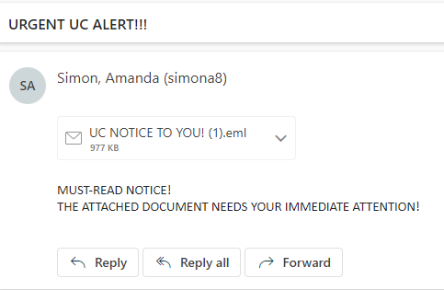

* + 7.2 Request for Login Credentials:
    - Legitimate organizations won't ask you to verify your password or personal information by clicking on links in emails. Always go to the official website by typing the URL in your browser.
    - To protect yourself, always verify the legitimacy of such requests by contacting your bank directly through their official website or customer service phone number. Avoid clicking on links or providing sensitive information through unsolicited emails like this one.

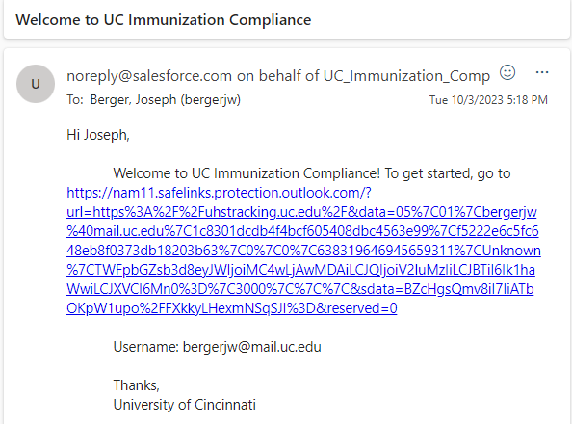

* + 7.3 Analysis:
    - In these examples, there are several red flags to note:
      * Urgency: The first email creates a sense of urgency by stating that the attached document requires immediate attention.
      * Suspicious Senders: Neither of these senders have a legitimate UC account and are impersonating a UC domain
      * Grammatical and Formatting Errors: Both of these emails have weird formatting inconsistencies or just blatant grammar errors.
      * Unverified Link: The provided link (in the second email) is not associated with the legitimate organization. Phishing links often mimic official websites, attempting to steal your login credentials and financial data.
* **Section 8: Look for Red Flags in Email Attachments**
  + 8.1 Suspicious File Types:
    - Be cautious with email attachments that end in .exe, .zip, or .js. These file types are common in malware distribution.

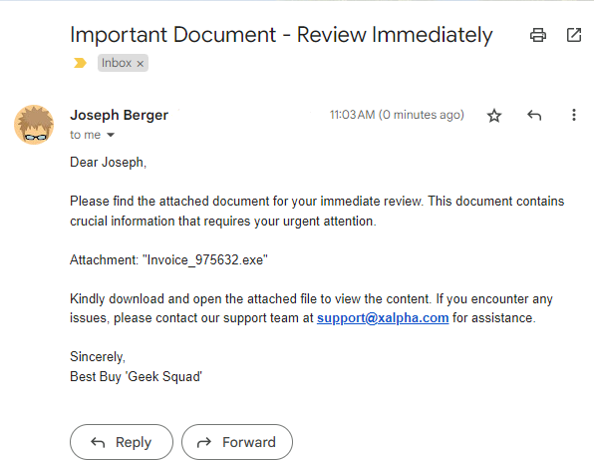

* + 8.2 Password-Protected Attachments:
    - Criminals may use password-protected attachments to evade antivirus scanners. Be skeptical of such attachments, especially if you didn't expect them.
  + 8.3 Analysis:
    - In this example, there are several suspicious elements to consider:
      * File Type: The attachment is named "Invoice_975632.exe." The .exe extension indicates that this is an executable file, commonly associated with programs and applications. Attachments in executable formats should raise a significant red flag in email communications.
      * Urgency and Unverified Sender: The email creates a sense of urgency and encourages you to open the attachment immediately. However, the sender's email address (support@xalpha.com) is not associated with the legitimate company. Phishers often impersonate trusted entities to lure recipients into opening malicious attachments.
      * Lack of Explanation: The email does not provide a clear explanation of the document's content or why it's essential. Legitimate organizations typically offer more information about the attachment's purpose.
      * In this case, the email attachment "Invoice_975632.exe" is highly suspicious. Executable files can contain malware, and opening such attachments could lead to system compromise or data loss. It's crucial to avoid opening any executable files received via email, especially if the sender's authenticity is in question. Always verify the source and purpose of email attachments before taking any action.
* **Section 9: Double-Check Email Signature and Contact Information**
  + 9.1 Verify Email Signatures:
    - Inconsistent Formatting: Phishing emails may have email signatures with inconsistent fonts, colors, or formatting. Legitimate organizations typically maintain a consistent and professional appearance in their email signatures.
    - Missing Official Contact Information: Legitimate emails from reputable organizations usually include official contact details such as physical addresses, phone numbers, and official website links in their signatures. Phishing emails might lack this information or provide inaccurate details.
    - Incorrect Positioning of Corporate Logos: Phishers often attempt to replicate company logos in email signatures. However, they may position the logo incorrectly, have a lower resolution, or include artifacts that differ from the genuine logo.
  + 9.2 Confirm Contact Information:
    - Unusual Email Addresses: Phishing emails often use email addresses that look similar to official ones but contain subtle misspellings or extra characters. Verify email addresses carefully, especially if they seem slightly off.
    - Mismatched Contact Information: Legitimate companies use consistent contact information across their communication channels. If the information in the email differs from the known official details, it could be a sign of a phishing attempt.
    - No Direct Contact Options: Phishing emails might lack direct contact options or provide generic email addresses (e.g., support@fraudulentcompany.com). Legitimate organizations usually provide clear and direct contact options for customer inquiries.
* **Section 10: Monitor for Unusual Email Domains**
  + 10.1 Check Email Domains:
    - Look for Misspellings or Variations: Phishing emails often use domains that resemble legitimate ones but contain subtle misspellings or variations.
      * For example, "legitcompany.com" might be impersonated as "legitcompnay.com."
    - Extra Hyphens or Characters: Cybercriminals may add hyphens, underscores, or additional characters to mimic a legitimate domain.
      * For instance, "yourbank-official.com" might be used to impersonate "yourbankofficial.com."
    - Unusual Top-Level Domains (TLDs): Phishers may use uncommon TLDs, such as ".biz" or ".info," instead of the standard ".com" or ".org." Legitimate organizations typically stick to well-known TLDs.
  + 10.2 Use Email Verification Tools:
    - Employ email verification tools to validate the authenticity of an email sender's domain. These tools can help identify email spoofing. Some examples of tools that are available to use by the public to check email domains are Google Postmaster, MSToolBox, Talos Itelligence, and Barracuda.
    - Legitimate companies use special codes to prove that their emails are real. Email verification tools can check for these codes and tell you if they are there.
      * These tools can look for signs that the email is coming from the right place. For example, if an email claims to be from your bank but the tool sees something unusual, it can warn you.
    - Cross-Check with Known Domains: Use email verification tools that cross-check the sender's domain with known and trusted domain databases. If a domain is not recognized or has a poor reputation, it could be a sign of a phishing attempt.
    - Automated Domain Analysis: Some tools automatically analyze the sender's domain for potential threats, providing insights into its reputation and history. This can be valuable in identifying phishing domains.
* **Section 11: Types of Malware in Phishing Emails**

Phishing emails may contain various types of malware, each with distinct characteristics and objectives. Understanding these types can help you identify and combat threats effectively.

* + 11.1.1 Trojans:
    - Trojans disguise themselves as legitimate files but contain malicious code. They aim to steal data, create backdoors for hackers, or compromise your system.
  + 11.1.2 Ransomware:
    - Ransomware encrypts your files and demands a ransom for decryption. It can disrupt operations and lead to data loss.
  + 11.1.3 Spyware:
    - Spyware covertly collects data from your system or activity. It's often used for espionage or stealing personal information.
  + 11.1.4 Keyloggers:
    - Keyloggers record your keystrokes, including passwords and sensitive information, which attackers can later access.
  + 11.1.5 Spear Phishing:
    - Spear Phishing includes attackers who claim to be the CEO of a certain company to trick, for example, finance executives into sending money to a certain bank account.
  + 11.1.6 Viruses:
    - A virus is a type of malicious software, or malware that spreads between computers and causes damage to data and software.
  + 11.1.7 Adware
    - Adware is software that displays or downloads unwanted advertisements typically in the form of banners or pop-ups.
* **Section 12: Differences Among Malware Types**

Understanding the differences between various types of malware is crucial in recognizing their potential impact and how they work.

* + 12.1 Infiltration Method:
    - Trojans and ransomware often infiltrate systems through infected files or links, while spyware and keyloggers are usually installed stealthily without user knowledge.
  + 12.2 Objectives:
    - Ransomware's primary objective is to extort money, while trojans aim to compromise security or steal data. Spyware and keyloggers focus on surveillance and data collection.
  + 12.3 Data Targeting:
    - Ransomware may encrypt a wide range of files, while spyware and keyloggers specifically target sensitive data. Trojans can vary in their objectives.
* **Section 13: Mitigating Malware Threats**

To prevent malware from phishing emails, you must employ various strategies and tools:

* + 13.1 Use Antivirus Software:
    - Install reputable antivirus software to scan email attachments and flag malicious content.
  + 13.2 Keep Software Updated:
    - Regularly update your operating system, software, and applications to patch vulnerabilities that malware might exploit.
  + 13.3 Practice Safe Browsing:
    - Avoid downloading files or clicking on links from unknown sources. Verify the authenticity of websites before providing sensitive information.
  + 13.4 Educate Students:
    - Ensure that students are trained to recognize phishing emails and malware threats, emphasizing the importance of not opening suspicious attachments or clicking on dubious links.
* **Conclusion:**

In conclusion, by following the guidelines provided and remaining vigilant, you can significantly reduce the risk of falling victim to email threats. It's essential to stay updated on the latest email security best practices and to educate yourself and your team on how to recognize and prevent email threats, ensuring safe and secure digital communications.

Phishing attacks are continually evolving, growing more sophisticated and difficult to identify. Your ability to combat these threats effectively relies on staying informed, applying critical thinking, and maintaining vigilance. Regularly updating your knowledge and security practices is paramount to preserving a secure online environment.

Understanding the different types of malware that can be delivered through phishing emails is crucial for your organization's cybersecurity. By recognizing these various threats, understanding their objectives, and employing effective preventive measures, you can bolster your defenses against malicious attacks. It's imperative to remain vigilant, keep your systems updated, and educate your team to maintain a secure digital environment.